Displayed ticker symbol in column I

VBA code

Sub tickername()

Dim tickername As String

Dim summary_ticker_row As Integer

summary_ticker_row = 2

'create headers

Cells(1, 9).Value = "Ticker"

Cells(1, 10).Value = "Quarterly Change"

Cells(1, 11).Value = "Percent Change"

Cells(1, 12).Value = "Total stock volume"

' last row to define

lastrow = Cells(Rows.Count, 1).End(xlUp).Row

' loop ticker name

For i = 2 To lastrow

If Cells(i + 1, 1).Value <> Cells(i, 1).Value Then

tickername = Cells(i, 1).Value

' add ticketname in the summary table

Range("I" & summary_ticker_row).Value = tickername

'reset counter for summary ticker

summary_ticker_row = summary_ticker_row + 1

End If

Next i

End Sub

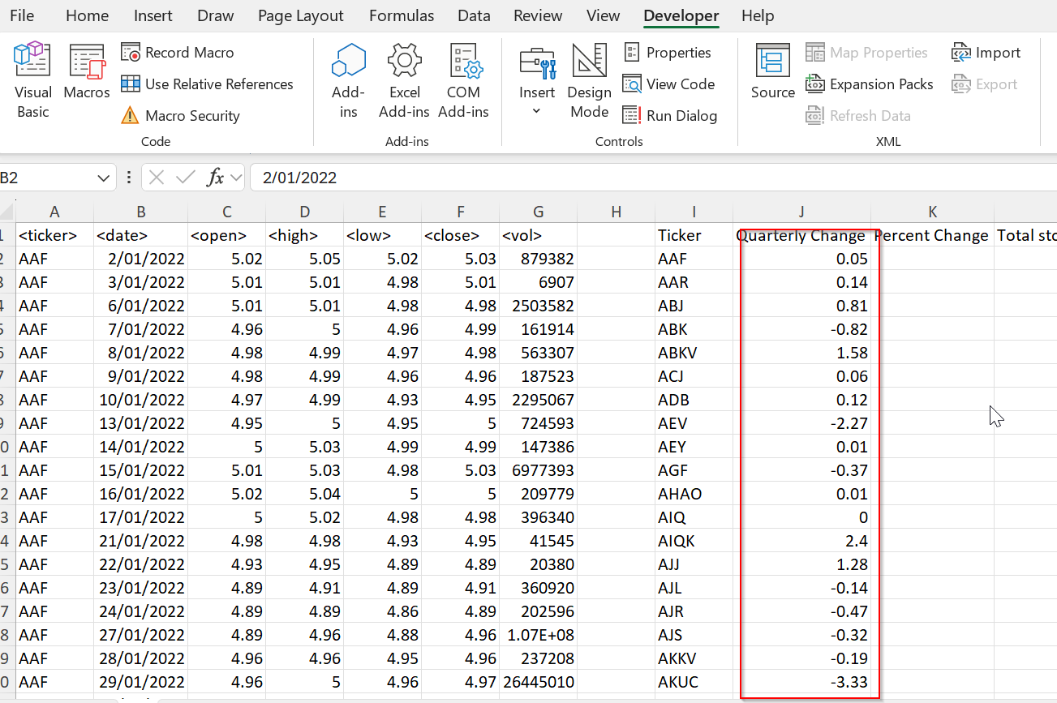

Sub quarterlychange()

Dim quarterly_change As Double

Dim open_price As Double

Dim close_price As Double

Dim summary_ticker_row As Integer

summary_ticker_row = 2

lastrow = Cells(Rows.Count, 1).End(xlUp).Row

open_price = Cells(2, 3).Value

For i = 2 To lastrow

If Cells(i + 1, 1).Value <> Cells(i, 1).Value Then

close_price = Cells(i, 6).Value

quarterly_change = (close_price - open_price)

Range("J" & summary_ticker_row).Value = quarterly_change

summary_ticker_row = summary_ticker_row + 1

open_price = Cells(i + 1, 3)

End If

Next i

End Sub

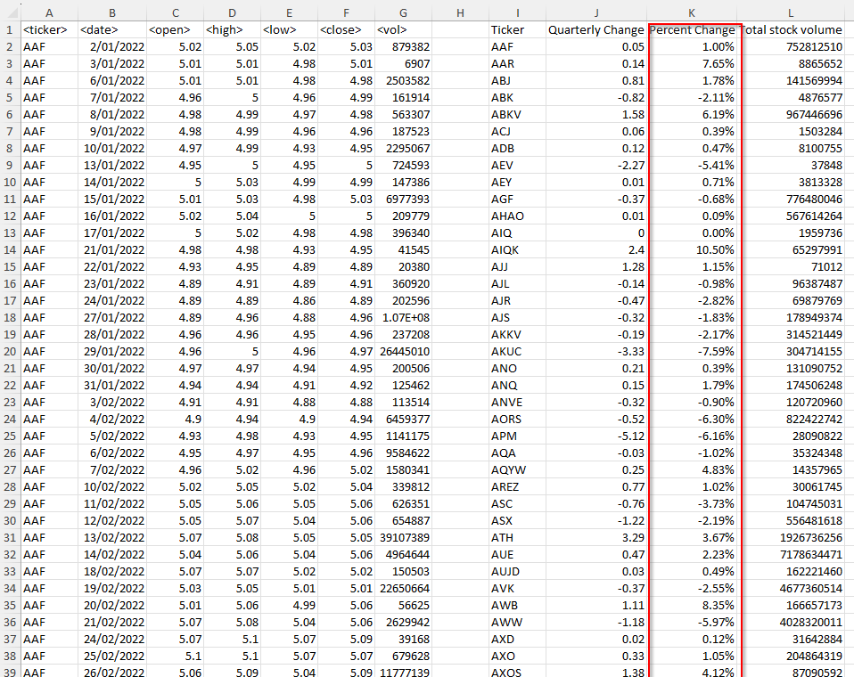

'This module is for percentage change

Sub percentagechange()

Dim open_price As Double

Dim close_price As Double

Dim percentage_change As Double

Dim summary_ticker_row As Integer

summary_ticker_row = 2

lastrow = Cells(Rows.Count, 1).End(xlUp).Row

open_price = Cells(2, 3).Value

For i = 2 To lastrow

If Cells(i + 1, 1).Value <> Cells(i, 1).Value Then

close_price = Cells(i, 6).Value

If open_price <> 0 Then

percentage_change = (close_price - open_price) / open_price

End If

Range("k" & summary_ticker_row).Value = percentage_change

summary_ticker_row = summary_ticker_row + 1

open_price = Cells(i + 1, 3)

End If

Next i

End Sub

'This module is for Total stock volume

Sub volume()

Dim volume As Double

Dim summary_ticker_row As Integer

summary_ticker_row = 2

Dim open_price As Double

Dim close_price As Double

open_price = Cells(2, 3).Value

volume = 0

lastrow = Cells(Rows.Count, 1).End(xlUp).Row

For i = 2 To lastrow

If Cells(i + 1, 1).Value <> Cells(i, 1).Value Then

volume = volume + Cells(i, 7).Value

Range("L" & summary_ticker_row).Value = volume

close_price = Cells(i, 6).Value

summary_ticker_row = summary_ticker_row + 1

volume = 0

open_price = Cells(i + 1, 3)

Else

volume = volume + Cells(i, 7).Value

End If

Next i

End Sub

'script to return the stock with greatest %increase and decrease and total volume

Sub FindStockStats()

Dim lastrow_summary_table As Long

Dim maxPercentChange As Double

Dim minPercentChange As Double

Dim maxVolume As Double

Dim i As Long

lastrow_summary_table = Cells(Rows.Count, 11).End(xlUp).Row

maxPercentChange = Application.WorksheetFunction.Max(Range("K2:K" & lastrow_summary_table))

minPercentChange = Application.WorksheetFunction.Min(Range("K2:K" & lastrow_summary_table))

maxVolume = Application.WorksheetFunction.Max(Range("L2:L" & lastrow_summary_table))

' label the cells

Cells(2, 15).Value = "Greatest % Increase"

Cells(3, 15).Value = "Greatest % Decrease"

Cells(4, 15).Value = "Greatest Total Volume"

Cells(1, 16).Value = "Ticker"

Cells(1, 17).Value = "Value"

For i = 2 To lastrow_summary_table

If Cells(i, 11).Value = maxPercentChange Then

Cells(2, 16).Value = Cells(i, 9).Value

Cells(2, 17).Value = Cells(i, 11).Value

Cells(2, 17).NumberFormat = "0.00%"

ElseIf Cells(i, 11).Value = minPercentChange Then

Cells(3, 16).Value = Cells(i, 9).Value

Cells(3, 17).Value = Cells(i, 11).Value

Cells(3, 17).NumberFormat = "0.00%"

ElseIf Cells(i, 12).Value = maxVolume Then

Cells(4, 16).Value = Cells(i, 9).Value

Cells(4, 17).Value = Cells(i, 12).Value

End If

Next i

End Sub

Final result

